Keynote Topics at Old Age Psychiatry Conferences Around the World
Dr Lianne Leung
South Metropolitan Health Service, Perth, Australia
Key highlights:
- Programs at recent geriatric psychiatry conferences were reviewed.
- Approximately half of the presentations were related to treatment and one-third were related to service delivery; however all conferences included some discussion of natural history and assessment.
- Most talks did not specify a disease focus and looked at the care of older adults in general; of those talks that did, 33% focused on dementia and 8% focused on depression.

Background
The scope of practice of a geriatric psychiatrist can vary depending on local culture and health systems. As a junior doctor from Perth, the most isolated capital city in the world, I have been curious about how things are done in other cities and health systems. I have wondered what geriatric psychiatrists discuss at conferences elsewhere.

Methods
On Google, the terms “psychogeriatric”, “geriatric psychiatry”, “old age psychiatry”, “congress” and “meeting” were searched, and I clicked through related results. Of the programs available, each line/talk was reviewed and tagged based on the topic. One of the older, excluded programs was used as a trial for the tagging methodology, so the tagging would be more consistent. For inclusion and exclusion criteria, I’ve limited the results to only since 2020, post-pandemic, and I only included prepared presentations using English. The social program, welcome events and posters were excluded from this review.

Results
A total of 191 talks across six conferences were included. The programs from the following conferences were reviewed, and the associated abbreviation was used throughout the subsequent article:
- Canadian Academy of Geriatric Psychiatry-Canadian Coalition for Seniors’ Mental Health Annual Scientific Meeting 2021 (CAGP-CCSMH 2021, n=36 talks)
- European Association of Geriatric Psychiatry-Royal College of Psychiatrists: Clinical practice in Old Age Psychiatry – an update 2021 (EAGP 2021, n=7 talks)
- NHS Leeds and York Partnership Old Age Psychiatry Conference 2022 (NHS Leeds 2022, n=6 talks)
- Royal College of Psychiatrists Faculty of Old Age Psychiatry Annual Conference (RCPsych 2023, n=30 talks)
- Royal Australian New Zealand College of Psychiatry – Faculty of Psychiatry of Old Age Conference: Ageing in the contemporary era 2023 (RANZCP 2023, n=34 talks)
- International Psychiatric Association 2023 International Congress (IPA 2023, n=78 talks)

What aspect of care was discussed?
Across conferences, there was considerable variation in the number of discussions on natural history, assessment, treatment and service delivery; the greatest focus was on treatment (~50%) and service delivery (~36%) (Figure 1). The longer conferences (RANZCP 2023, IPA 2023, RCPsych 2023 and CAGP-CCSMH 2021) also included sessions on physician and caregiver well-being.

What types of treatments were discussed?
All conferences had some mention of pharmacological treatment, and most also included non-pharmacological approaches to treatment. When all conferences were combined, there were an equal number of talks (n=23) exploring non-pharmacological approaches that incorporated technology as compared to those not incorporating technology. This is compared to the 16 talks exploring pharmacological approaches to treatment. Regarding neurostimulation, there were four sessions on ECT across included conferences, and IPA 2023 was the only conference that had sessions focused on TMS.

Was there a disease focus?
Across the conferences, there was variability in the number of discussions on dementia, depression, and other disorders. Most talks didn’t specify a disease focus, and of those that did, 33% were about dementia and 8% were about depression (Figure 2).

Who are the talks for?
The majority of talks were about patients, and the longer conferences had sessions specifically discussing patients in long-term care. CAGP-CCSMH 2021 and IPA 2023 had several sessions discussing research related to carers and families, and RANZCP 2023 included a session with carers and people with lived experience.

Was it about COVID?
An older program (CAGP’s 2020 conference) was included to allow for a better comparison. COVID went from being the focus in 26% of all talks in 2020 (n=9 out of 34 talks) to 1% of all talks in 2023 (n=2 out of 144 talks).

Discussion
Having commenced this review seeking cross-conference and cross-cultural differences, I was surprised to find that the focus on treatment and service delivery was consistent across the board. Furthermore, most talks did not specify specific diseases; rather, they discussed the care of older adults in general. Where it was specified, dementia was the most common topic across conference Regarding treatment, there were more than double the number of talks on non-pharmacological management compared to pharmacological, but very few on neurostimulation. This may be a positive reflection of the global focus on minimizing polypharmacy in older adults, and efforts to build an evidence base for novel non-pharmacological treatments. Finally, another positive finding was that the longer conferences included program aspects dedicated to the well-being of physicians and caregivers; this is essential both for fostering individual work satisfaction and for building a healthy, sustainable workforce to best serve our communities.

Limitations
This was a brief, informal review, and there were almost certainly eligible programs that were not included. Additionally, an element of cross-cultural learning was lost by only including presentations given in English; it was mentioned that someone might want to expand this review to include non-English presentations.
The validity of this approach to classifying talks is also questionable as it depended on assumptions about a talk’s content based on its title. Indeed, upon attending the RANCZCP 2023 Conference in Melbourne, it soon became clear that almost every presentation had some discussion of service delivery and local health systems, and some also discussed the impact of COVID, although I had not classified the presentation as such.

Conclusion
This informal review summarizes similarities and differences across psychiatry conferences around the world. Thank you to all the organizing committees behind the conferences; and to all the speakers who presented, without whom this would have been a much briefer article; and to delegate members who joined the conference discussions. Conferences are valuable learning and networking opportunities, and I encourage you to explore events upcoming in 2024.

Further reading
The programs reviewed here were previously freely available on the internet.
I encourage you to look up your local and international old age psychiatry conferences for 2024.

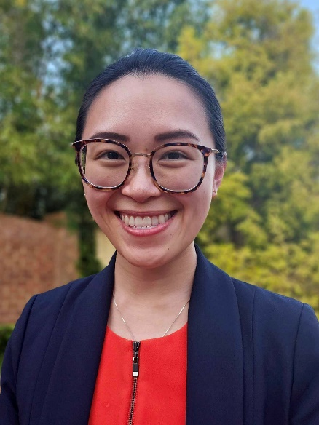
Dr Lianne Leung is a first year psychiatry trainee from Perth with an interest in older adult mental health and doctors’ welfare. Please send queries to lianneleung.medicine@gmail.com

